Publish and Deploy an Agent in Microsoft Copilot Studio
Learning Objective
Learn how to publish an agent using the new Copilot Studio Agent Experience, understand the publishing lifecycle, configure publishing channels, and verify the published agent.

Exercise 1 – Verify Agent Readiness

Step 1: Open your Agent
- Sign in to Microsoft Copilot Studio.
- Open the agent created previously.
- Ensure you are using the New Agent Experience.

Step 2: Review Agent Information
Verify that the following are completed:
- Agent Name
- Description
- Instructions
- Knowledge Sources (optional)
- Actions/Skills (optional)

Step 3: Test the Agent
Open the Preview tab.
Ask questions such as:
Hello

What can you help me with?

Summarize your capabilities.

Verify:
- Responses are accurate
- No errors occur
- Agent follows instructions
Expected Result:
The agent behaves correctly during testing.
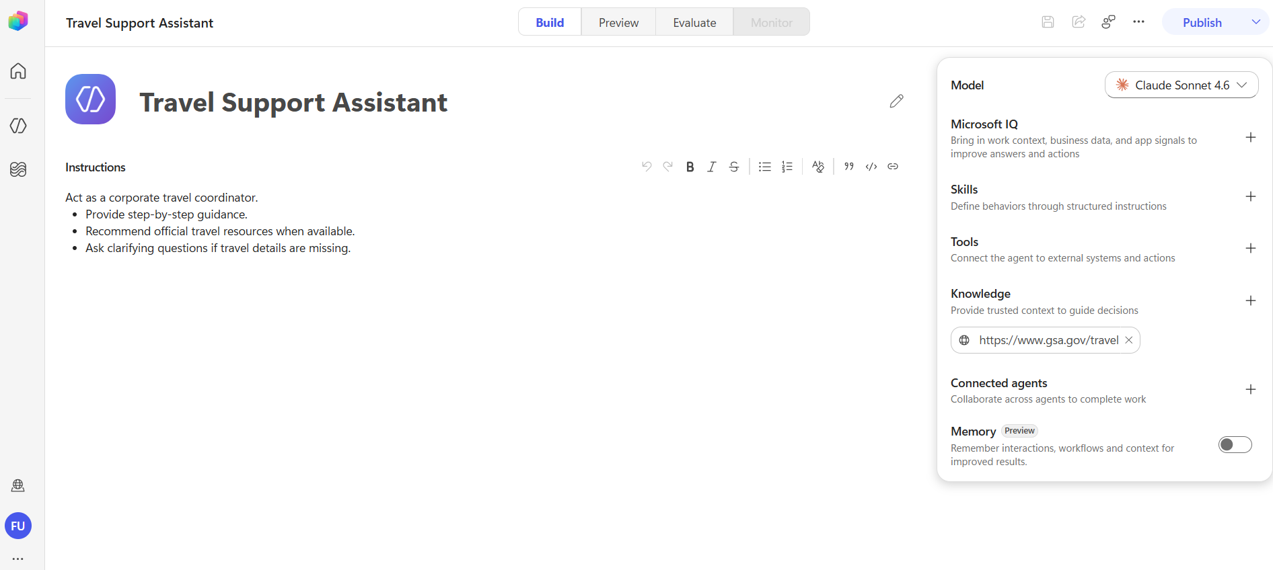

Exercise 2 – Publish the Agent

Step 1: Start Publishing
Select Publish ▼ from the upper-right corner.
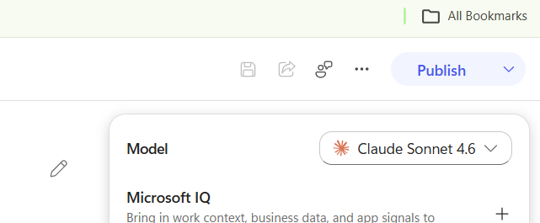

Step 2: Review Publishing Details
Review:
- Agent Name
- Description
- Selected Channel(s)

Step 3: Publish
Click Publish
Wait until publishing completes.
Expected Result:Status changes to Published / Live
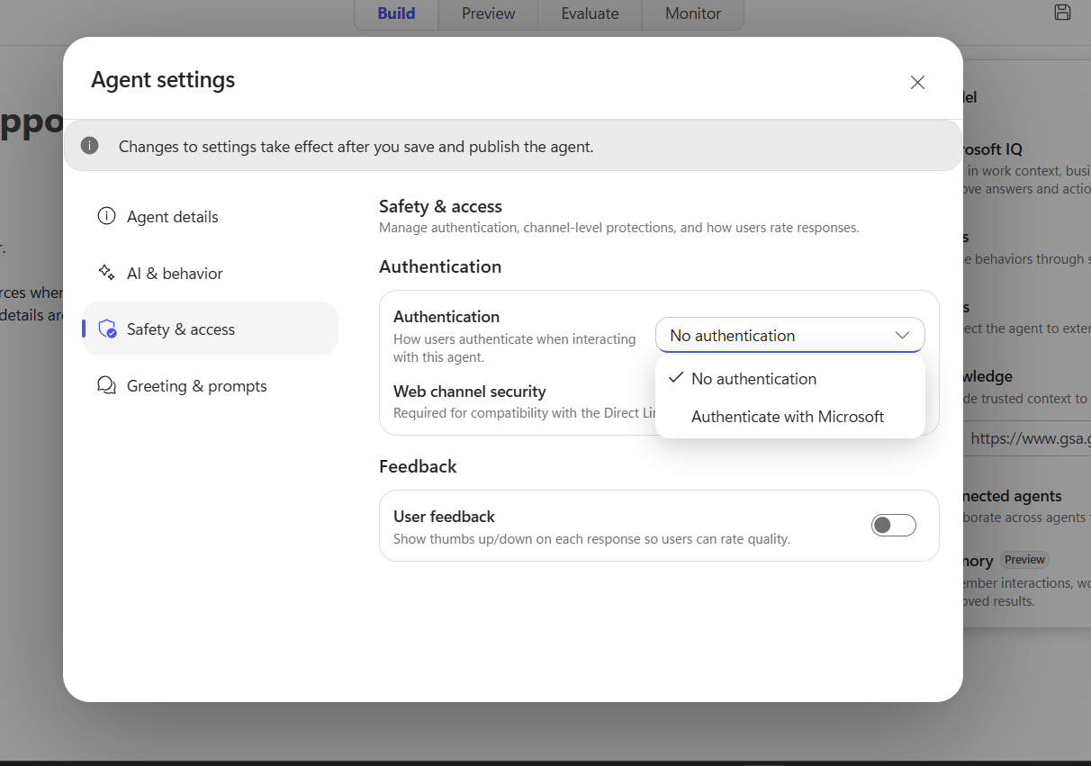

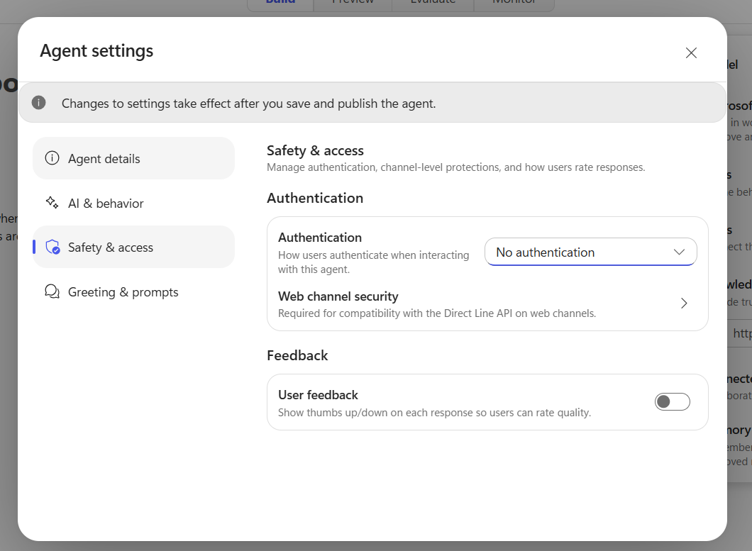

Exercise 3 – Understand Publish States
Observe the publishing status.
Possible states include:
State | Meaning
Not Yet Published | Draft only
Publishing | Deployment in progress
Published / Live | Agent available through selected channels
Publish Failed | Deployment unsuccessful
Expected Result:
Agent status shows Published / Live after successful deployment. (Microsoft Learn)

Exercise 4 – Understand Versioning
Modify the Instructions.
Example:
Always answer in a professional tone.

Save changes.
Do NOT publish yet.
Open Preview.
Notice:
- Preview uses the latest draft.
- Live users continue using the previous published version.
Now click
Publish
Expected Result:
A new version replaces the previous live version. Draft changes become available only after republishing. (Microsoft Learn)

Exercise 5 – Review Publishing Workflow
Understand the publishing lifecycle.
Create Agent
│
▼
Build Agent
│
▼
Preview & Test
│
▼
Publish
│
▼
Live Version Created
│
▼
Connect Distribution Channels
│
▼
Users Access Agent

Expected Result:
You understand the complete deployment lifecycle.

Exercise 6 – Share the Published Agent
After publishing successfully, explore available sharing options.
Possible options include:
- Share Agent
- Add to Organization Catalog
- Configure Distribution Channels (such as Microsoft 365 Copilot or Microsoft Teams, depending on licensing and availability)
Publishing creates the live version, but users can only access it through configured channels. Available channels and setup vary by environment and licensing. (Microsoft Learn)

Challenge Exercise
Update your agent so it can answer:
What services do we provide?

Test the response.
Publish the updated version.
Verify that:
- Preview reflects draft changes immediately.
- Live users receive the updated behavior only after publishing.

Knowledge Check
Q1. Does Preview automatically update the published agent?
Answer: No

Q2. What creates a new live version?
Answer: Publishing the draft

Q3. Can you continue editing after publishing?
Answer: Yes, changes remain in draft until republished.

Q4. Which lifecycle correctly represents the new Agent Experience?
- Build
- Preview
- Publish
- Monitor
Answer: All of the above

